CODE FOR THE ASSIGNMENT

#include <stdio.h>

#include "pico/stdlib.h"

#include "hardware/gpio.h"

#include "pico/time.h"

#define LED_PIN 9

#define TOGGLE_BUTTON 1

int toggle = 0;

void blinkLed(int count, int delay_ms) {

for (int i = 0; i < count; i++) {

gpio_put(LED_PIN, 1);

sleep_ms(delay_ms);

gpio_put(LED_PIN, 0);

sleep_ms(delay_ms);

}

}

int main() {

#ifndef PICO_DEFAULT_LED_PIN

#else

stdio_init_all();

gpio_init(LED_PIN);

gpio_set_dir(LED_PIN, GPIO_OUT);

gpio_init(TOGGLE_BUTTON);

gpio_set_dir(TOGGLE_BUTTON, GPIO_IN);

gpio_pull_up(TOGGLE_BUTTON);

while (true) {

if (!gpio_get(TOGGLE_BUTTON)) {

toggle = !toggle;

sleep_ms(100);

}

if (toggle == 0) {

blinkLed(10, 3000);

blinkLed(20, 1500);

blinkLed(30, 1000);

} else {

blinkLed(30, 1000);

blinkLed(20, 1500);

blinkLed(10, 3000);

}

}

#endif

}

SOLUTION OF QUESTION 2

[0 to 3.3V] to [-1.65 to 1.65V]

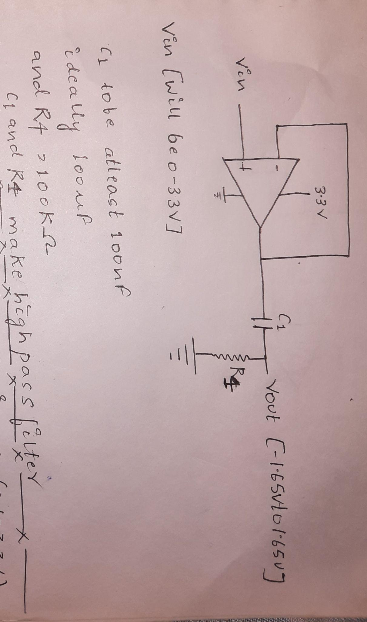

[-1.65V TO 1.65V] to [0 to 3.3V] 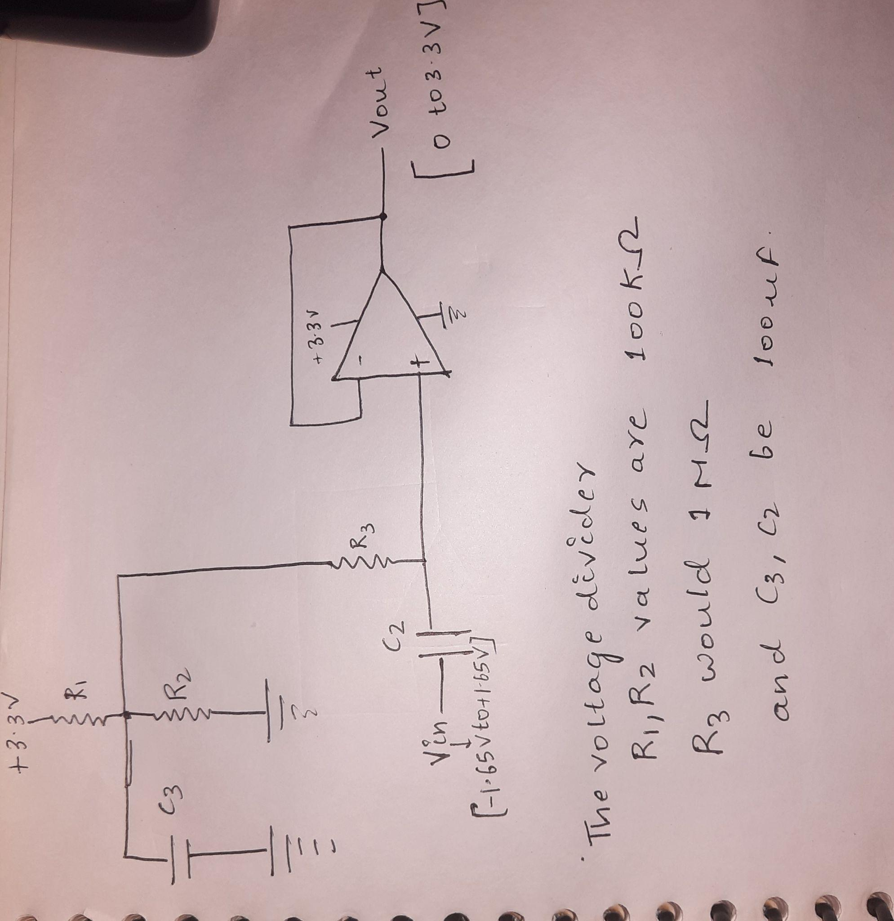

SOLUTION OF QUESTION 3

The topology-1 is parallel then series

The pros of this topology:-

1. The relative cost of this topology is better than topology-2
2. The topology is able to maintain easy control
3. In this case the battery pack can be managed by one BMS.

The cons of this topology:-

1. There is not any redundancy in the battery pack.
2. It is only during the design and manufacture the capacity of the pack is known.

The topology-2 is series then parallel

The pros of this topology:-

1. Compared tho topology-1 there is redundancy
2. Scalability is economical
3. The sizing is also flexible

The cons of this topology:-

1. The cost of this topology is higher than topology-1
2. BMS should be present at each string present in series
3. In case of any unbalance condition that strings needs to be open circuit
4. Switch gear and fusing is also required at each string in series
5. Since each string should have BMS a master BMS is also required to control the operations of the battery pack.